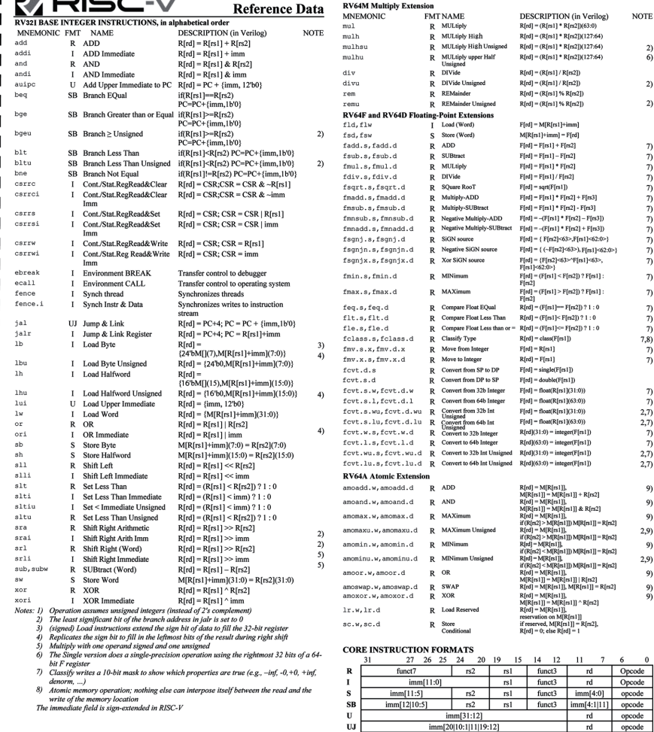

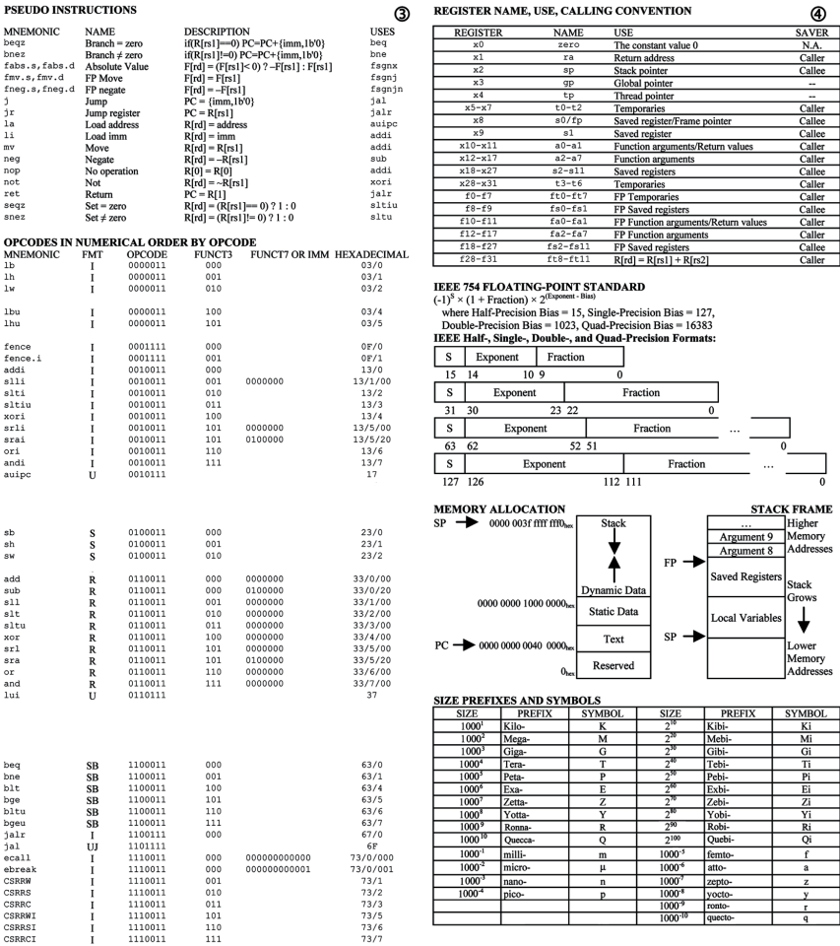

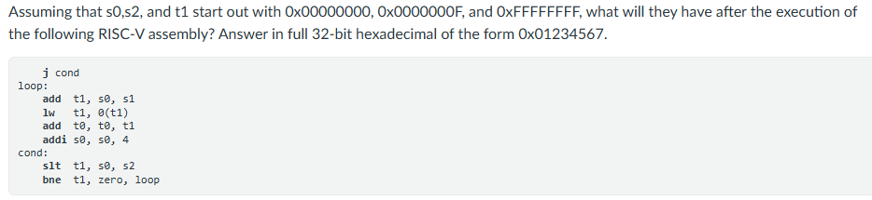
0x00000010
0x0000000F
0x00000000
# Instructions A: 27
# Instructions B: 27

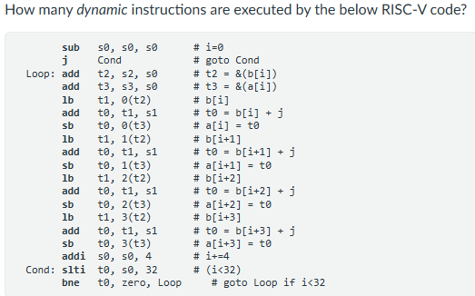
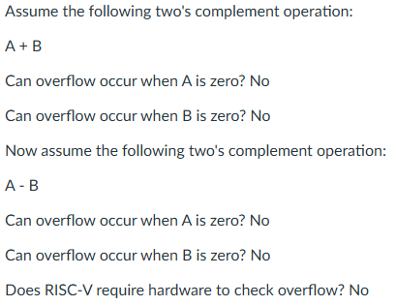
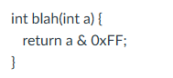
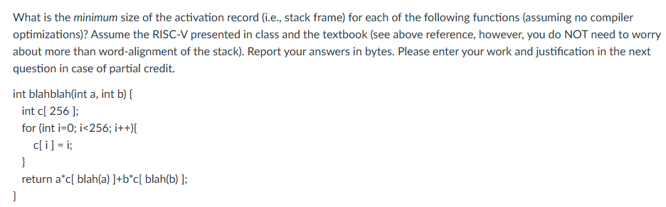
ANSWER: 1036 = 256*4 + return address (4) + a (4) + b (4) {need to save a/b for surviving blah calls}
ANSWER: 0 – no arrays, no internal function calls, no updating variables

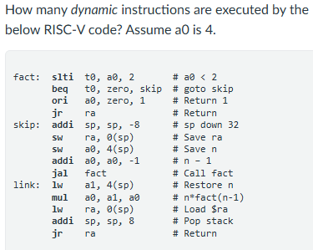
Pass1:4 – 2in – stck:0
Pass2:3 – 9in – stck:-8
Pass3:2 – 16in-stck:-16
Pass4:1 – 23in – stck:-24
Link1: stck:-24 – 25+5in
Link2: stck;-16 – 30+5in
Link3: stck:-8 – 35+5in
Stack: -24: Link,-20: 2, -16:Link, -12:3, -8: Caller, -4:4
Mul1: a0 = 2*1
Mul2: a0 = 3*2 = 6
Mul3: a0 = 4*6 = 24

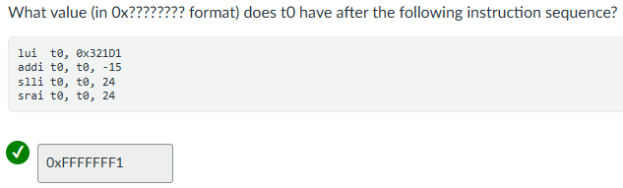

0x321D1000
0x321D1000 + 0xFFFFFFF1
0x321F0FF1 << 24 = 0xF1000000
0xF1000000 >> 24 = 0xFFFFFFF1

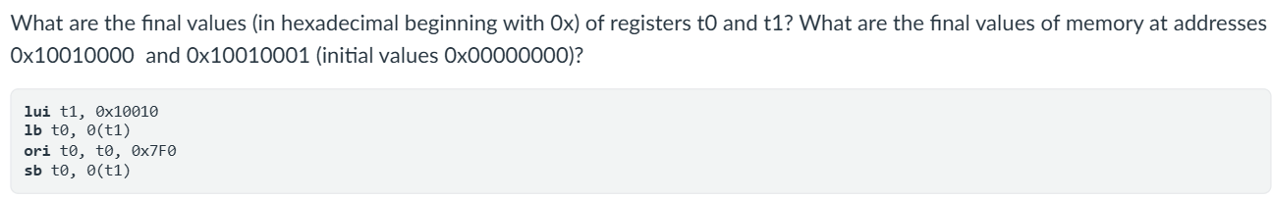
t1 = 0x10010000
t0 = M[0x10010000]
t0 = 0x000007F0
M[0x10010000] = 0x000000F0
M[0x10010001] = 0x00000000
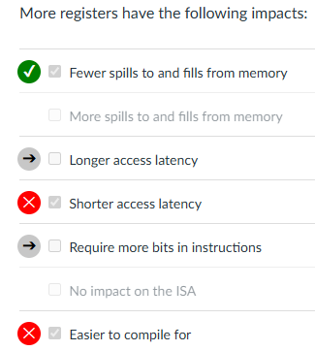
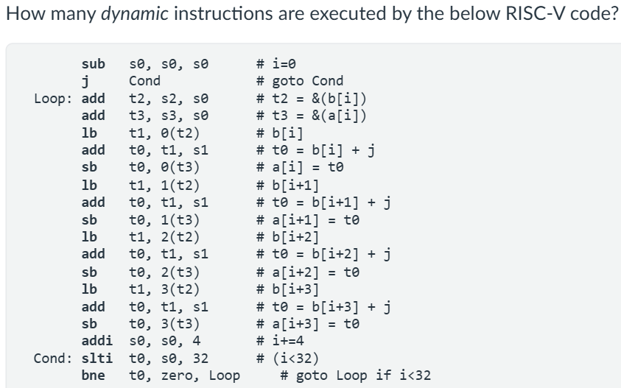

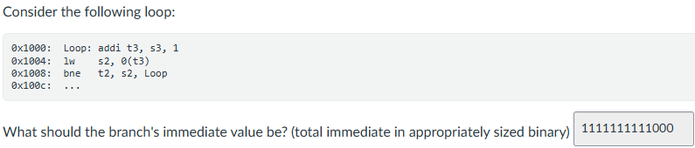

It depends on if the legacy code includes instructions that assume and need x0 to be 0. If these were included in the code, no, it can’t be updated without including new instructions. If they’re not, it could potentially.

